REQUIREMENTS DOCUMENT
PROJECT NAME: |  |  | Type
Core Colors in Colors By Brand |  |  | New Feature
STAKEHOLDER |  | US UI/UX:
Jon Fox
BA AUTHOR:
Patricia Marzan
PROJECT MANAGER:
Rose Ann Llamasares
DEVELOPMENT TEAM: (INCLUDING UI/UX)
Leslie Layug
SQA TEAM:
Ofelia Castro
OTHER TEAMS:
Criselle David
PRIORITY: |  | BRAND:
Critical |  | ALL

VERSIONS
VERSION NO. | BR/FR NO. | REVISION REMARKS | LAST UPDATED DATE
v1.0 | n/a | INITIAL RELEASE | March 26, 2026

PROJECT INITIAL REQUIREMENTS FROM STAKEHOLDERS
Goal
Give the Brand/Admin a way to mark one of their colors as a "Core Color"
Background
With the Customizer Reskin we are introducing "Core Color". These colors are the Brand recommended color.
Potential solution
let add something to the the Color by Brand page that an admin can select to indicate if a color is one of their Core colors. Maybe add a recommended color toggle on the index page linked to a single select drop down in each color page, like we do for the active toggle.

QX7 CHECKLIST
SECTION | YES/NO | NOTES
QX7 PAGES | YES | QX7 → MASTER DATA → COLORS → COLORS BY BRAND
FE IMPLEMENTATION | YES | Customizer Reskin ‘Core Colors’ Classification In Color Picker Modal
SYSTEM PERFORMANCE

CUSTOMIZER CHECKLIST
SECTION | YES/NO | NOTES
BUILDER | YES | Customizer Reskin ‘Core Colors’ Classification In Color Picker Modal

PRODUCTS CHECKLIST
SECTION | YES/NO | NOTES
ALL | YES

SPECIAL BLOCKS CHECKLIST
SECTION | YES/NO | NOTES

PROJECT REQUIREMENTS

BUSINESS REQUIREMENTS (BR)
NO. | NAME | DESCRIPTION
1 | PROCESS FLOW | QX7 → MASTER DATA → COLORS → COLORS BY BRAND

FUNCTIONAL REQUIREMENTS (FR)
NO. | NAME | DESCRIPTION
1 | COLORS BY BRAND INDEX PAGE | 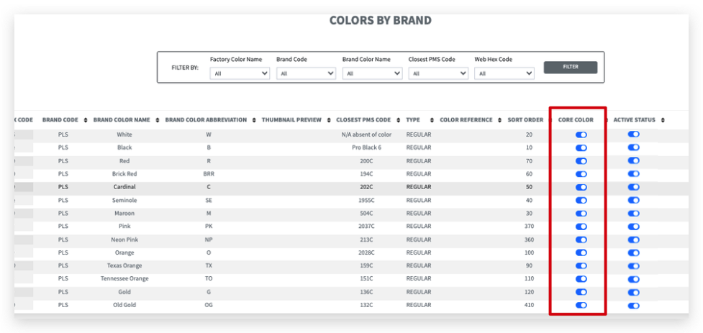
2 | EDIT COLOR BY BRAND | 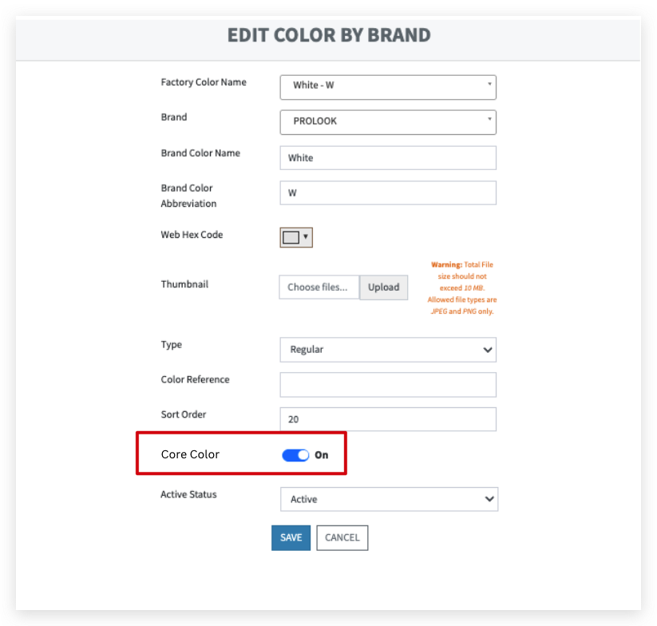
3 | FE IMPLEMENTATION | RD_CUSTOMIZER MENU RESKIN  - COLOR IN USE Modal Functionality  - Colors In Use  - Colors in Use will display the default colors of the uniform upon loading, or the colors applied from the Picker page  - The user can change the colors by clicking each color tile  - Upon clicking the color tile, color picker will be displayed below the selected section  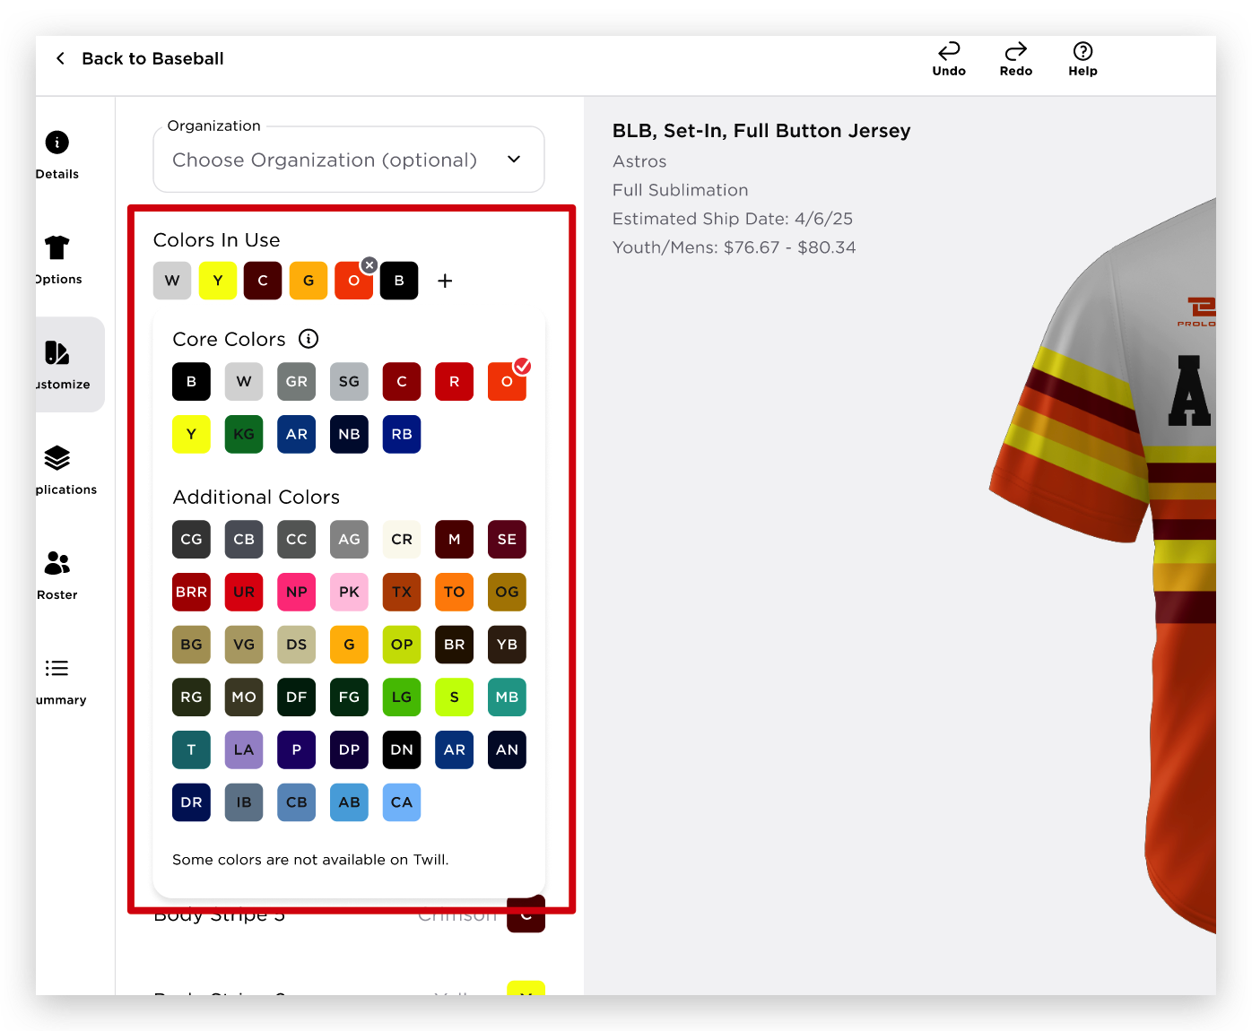  - Core Colors are set of colors determined by the brand  - Additional Colors will be the other colors other than the Core Colors

OUT OF SCOPE REQUIREMENTS
NO. | NAME | DESCRIPTION

PHASED IN REQUIREMENTS
NO. | NAME | DESCRIPTION |  | REASON OF PHASING IN

REFERENCES
NAME | LOCATION
Final Design Figma Link
Monday ticket | https://prolook.monday.com/boards/1080284252/pulses/11560187606/posts/5030504067
Hand-off Video
Technical Specs
JIRA Ticket

